Our team had a meeting today, and the following questions need to be reconfirmed with your team:

- Functionality of the RGB lights and layout design on the device

Assume WS2812C LEDs - we should have a connector on the board so we can be flexible with RGB layout, etc. Expect to have some mechanical mount for vertical LEDs.

2. Network pairing method (we recommend Bluetooth + Wi-Fi) , any special paring process your team requires : such scan barcode to add device into App, AP method, STA method ? We can send our samples to your team for the WiFi pairing reference. We always use WiFi + Bluetooth ways to make WiFi connection fast and stable

BLE + WiFi; Prototype already has - we might migrate to Improv WiFi (https://www.improv-wifi.com/)

3. MQTT communication protocol, we normally use this.

This is what we are baselining through AWS IoT

4. What data does the device need to upload, its format, and the upload interval?

TBD, but let’s baseline 15 minute updates of sensor readings and support event driven messaging for ambient lights, etc.

5. Hardware control commands for brightness, sound volume , open and close , Music play, and what’s else ?

I’m putting together an ICD (Interface Control Document) for this.

- There's a circular part with a logo on the top,what is its function? Pls check the drawing attached
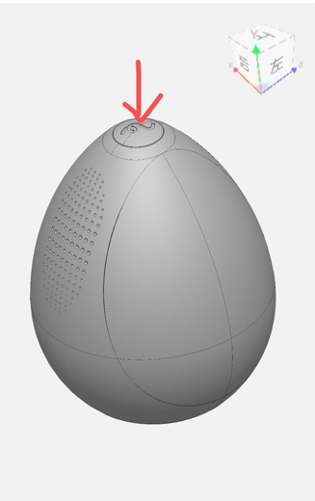

Action button. We should decide on where we want other buttons - do we want a power button (Amazon Echo has no power button), mute, etc. Do we want touch sensor rather than click on the top

7.For OTA, please refer and follow to the ESP32 OTA documentation. If any questions , we can provide OTA technical support.
Yes, will use standard ESP32 OTA

8.How is AI voice-control working when the wifi is online or offline , how to avoid the AI voice control being affected during the music-play’s sound beyond 85dB ?

We will have some basic wake word and local command ability - testing that today. Expect to lower volume when wake work is detected for better comprehension.

- Should program voice command words or sentences into ESP chip in advance if we choose ESP with built in voice control chip .

Yes, ESP-SR can support a limited vocabulary - testing today.

Until now we have those questions to be confirmed ，kindly check and feedback to us one by one，thanks！

